***PLEASE SAVE THE DATE***

***FOR THE 2017 HEALTH-CAREERS EXPLORATION***

***SUMMER INSTITUTE (HESI) STUDENT FINAL PRESENTATIONS!***

***When*:**

***Thursday, August 10, 2017***

***5:30p.m.-8:00p.m.***

*Doors open at 5:30. Presentations begin promptly at 5:45.*

***A catered dinner will be provided following the presentations.***

***Who/What:***

*The 10 HESI program students will be giving final presentations highlighting their internship experience at Adventist Health, Ukiah Valley.*

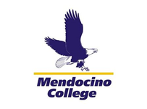

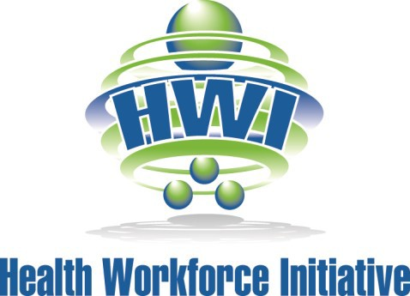

***Where*:**

Dora’s Gourmet Cafe

*263 North State Street*

*Ukiah, CA 95482*

***Please reserve your seats by Tuesday, August 8th, 2017 by contacting Jonica Vice.***

***E-mail: jcrook@uusd.net or Phone: 707-621-1441***

