NEWSLETTER DIRECTIONS
ROTATION TITLE
NAME

ROTATION DESCRIPTION  - Summarize in 1-2 paragraphs of what occurs, what you will see, types of procedures, typical patients, etc. for this rotation. | EQUIPMENT  - In bullet form list at least 3-4 different types of equipment SPECIFIC to this rotation you will see in use and for each explain in 2-3 sentences what the piece of equipment is used for  - Include pictures of equipment if you can  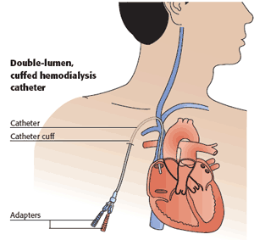
JOBS/CAREERS
- In bullet form list at least 3-4 different jobs/careers you will see in this rotation and for each job career:

- Give a short job description
- Explain the education needed for that job/career and whether there are any local colleges/universities that offer that program
- Give a salary range

COMMON PROCEDURES  - In bullet form list at least 3-4 different procedures you will see in this rotation and in at least 1 paragraph per procedure explain how it is done  - Include 1 diagram of common procedure done  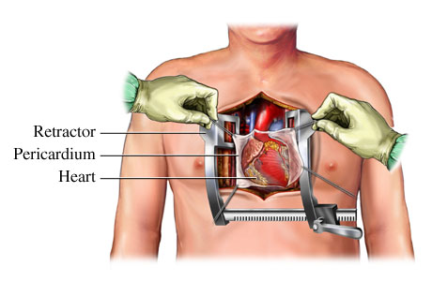 | ANATOMY FOCUS – W/DIAGRAM  - List the Anatomy & Physiology knowledge that will benefit you in this rotation (2-3 paragraphs minimum) and at least 1 useful anatomy diagram.  - EXAMPLE – Cath lab should have extensive information about the heart and even a diagram would be useful!!!!  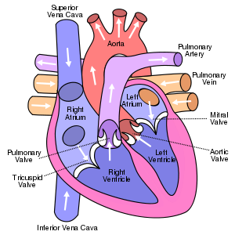

COMMON TERMINOLOGY  - Find and define a MINIMUM of 10 medical terms/abbreviations specific to this rotation. | OTHER  - Any additional information that would be useful such as contacts, bathroom codes, things to not forget- like DON’T TOUCH ANYTHING IN SURGICAL ROOMS!!! Etc.
PERSONALITY TRAITS  - Is this a high/low stress environment?  - What type of personality is best suited?  - How do you think you will handle this rotation? | NOTES  - Leave a space to record any additional information while you are in the rotation
ROTATION INFORMATION SHEET
DIRECTIONS: Follow the example above and complete a rotation information sheet for each rotation you attend. You will need to print out two copies of your information sheet – 1 for the instructor and 1 to keep as a cheat sheet while you are in that rotation.
The newsletter should only be 1 page front/back so you can bring it with you on your rotation. You can do your newsletter in a normal page format or brochure-style as well, but make sure to include all of the above information. Please make sure to include the titles!

YOU WILL NOT ATTEND YOUR ROTATION WITHOUT THIS SHEET!!!!

