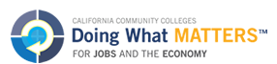
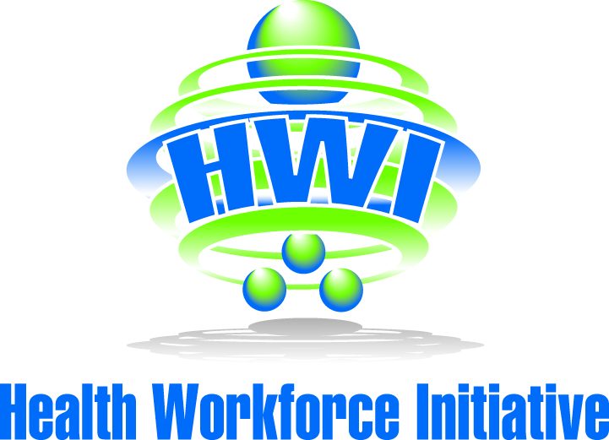

HEALTH-CAREERS EXPLORATION SUMMER INSTITUTE (HESI) OVERVIEW

DESCRIPTION:
HESI is a three week summer institute opportunity for students who are enrolled in a medical health pathway program in the far north counties. Students will be exposed to hospital careers, participate in rotations at a hospital and job shadow various departments. They will be given nightly homework and be required to do a final presentation to the hospital staff, school administration, teachers, family and friends. Students may receive credits for work experience.

REQUIREMENTS:
- Students must be enrolled in a medical health pathway program
- Students must have a GPA of at least 2.5 and be passing all classes
- Students must have completed Biology and Chemistry and be enrolled in Anatomy and Physiology
- Students must be a high school student and at least 16 years of age
- Students must submit and complete the following:
  - Application and paper explaining why they would like to be part of this experience
  - Submit a Health Pathway Teacher Verification/Recommendation Form
  - Interviewed by a selection panel

OVERVIEW OF THE SUMMER INSTITUTE:
Week 1:
- Orientation
  - Classroom time to get students acquainted with the hospital and go over expectations for the program.
- Discussion items:
  - Introductions, Medical Terminology, HIPAA Regulations, Overview of Rotations, Personal Protective Equipment and Safety Activities (hand washing, masks, hairnets, etc.), Behavior Expectations, Hospital Etiquette
- Homework expectations:
  - Rotation Newsletters, Case Studies, Final Presentations
Weeks 2 and 3:
- Students take part in hospital rotations. They are placed with a preceptor at a department and job shadow.
- Possible Rotations: Catheter Lab, ER, PT/OT, Pulmonary, Women’s Center, ICU, OR, Pre/Post-OP, Endoscopy, Laboratory, Pharmacy, Radiology
- Student involvement at each rotation:
  - Job shadowing:
    - What are procedures and responsibilities of the department?
  - Tasks:
    - Help with basic hospital skills (making beds, moving equipment, holding materials, etc.)
  - May NOT do:
    - Students may NOT come in contact with ANY bodily fluids even if they have personal protective equipment on.

FINAL PROJECT:
- At the end of the three weeks, students will compose a PowerPoint presentation and present their experiences to a panel of hospital staff, school administrators, teachers, family members, and friends.

Questions may be directed to:
Ellese Mello, HWI Pathway Coordinator (530) 521-2472 or emello@husdschools.org
Trudy Old, HWI DSN Far North (530) 879-9049 or oldtr@butte.edu

