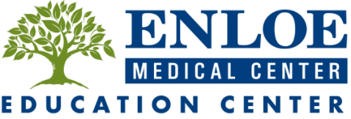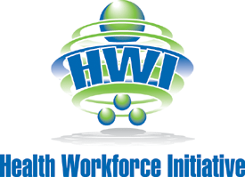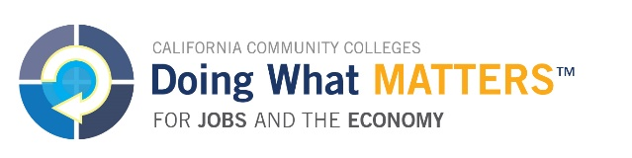

Certificate of Completion

this certifies that

**Kassiah Henderson**

has successfully completed

the 2015 Health-Careers Exploration Summer Institute (HESI)

at Butte College Skyway Center and Enloe Medical Center

June 15, 2015 to July 2, 2015

July 2, 2015

Ellese Mello, HWI Health Pathway Coordinator

Date