 | Program Partners  Enloe Education Department  - Mary Latimer, Director of Education  Enloe Medical Center  - Cardiac Care Unit  - Emergency Room  - Laboratory  - Mother Baby Unit  - Neurotrauma Intensive Care Unit  - Post-perianesthesia care (Post-PACA)  - Pre-perianesthesia care (Pre-PACA) and Surgery  - Radiology  - Respiratory Therapy  - Surgical Care Unit  Enloe Rehabilitation Center  - Occupational Therapy  - Physical Therapy  - Speech Therapy  Enloe Wound Center  Enloe Recruiting Department – Kimberly  Enloe Employee Health Services – Kim and Cindy  Feather River College SB1070 mini-grant funds  Butte-Glenn Career Pathways Consortium  San Diego Health and Science Pipeline Initiative (HASPI) | 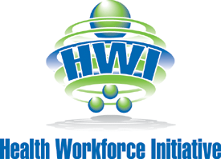  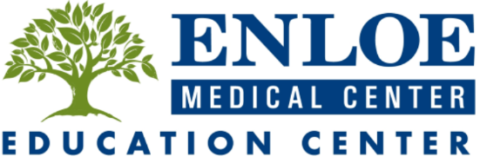 | Health-Careers Exploration Summer Institute (HESI)  Student Final Presentations  July 2, 2015 at the Enloe Conference Center
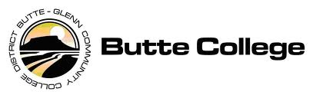

Special thanks…
The Health Workforce Initiative would like to extend a very special thank you to the people who came together to make this incredible experience possible for the students.
June 2015 was the pilot for the HESI program. Students spent three weeks in class and at hospital rotations gaining amazing hands-on experiences as they explored various careers in healthcare. The students received a warm welcome from the staff at Enloe Medical Center, Enloe Rehabilitation, and Enloe Wound Center. The staff generously donated their time to help this next generation of medical professionals explore the many facets of healthcare. They brought the Enloe patient centered care to life for the students. Thank you Enloe!
Thank you to the teachers. The students were well prepared for this program by the medical health and science pathways offered at their high schools. The preparation they received made their experience in the program more meaningful.
Thank you to the family members who supported their students.

Thank you from the Health Workforce Initiative and Butte College Team:
- Susan Craig, Butte College Nursing Director/Instructor
- Ellese Mello, HWI Pathway Coordinator
- Trudy Old, HWI Director
- Jessica Filice, HWI Professional Services

program agenda
5:30 | Meet and Greet
5:45 | Welcome – Denise Adams, Butte College CTE Dean
5:50 | Introduction – Trudy Old, HWI Director
5:55 | Student Introductions – Susan Craig and Ellese Mello, HESI Instructors
6:05 | Student Presentations
7:20 | Dinner
7:50 | Student Completion Certificates
8:00 | Acknowledgements & Closing Remarks

