Meet the Students of HESI 2015

Nanci Chavarria Villa
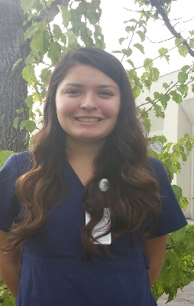
Hello, my name is Nanci Chavarria Villa and I live in Corning. I am 18 years old and just recently graduated from Hamilton High School. I am so excited to start a new chapter in my life during the fall. I will be attending UC Davis and will be majoring in biochemistry and molecular biology and look forward to attending medical school. The obstacles in life and the hindrance in one’s path are the motivation for dreams and goals that we clasp onto so tightly that helps us progress in life. Someday I dream of becoming a prestigious and illustrious doctor that will help others and expect absolutely nothing in return. My hunger for learning and my passion for the medical field motivated me to become involved in the HESI program. I knew that I would not only grow as a person, but I would grow intellectually as well and this experience was once in a lifetime; I couldn’t miss it. When I heard what we would get to see and experience in this program, I felt so intrigued and excited. Whether it was intricate surgeries I observed or a baby being brought into the world, words can’t describe how this program affected me. I became a more humble person and solicitude embraced me. As I saw families and patients in pain, I felt that pain and was compassionate towards others. Ever since I was a little girl I’ve been dreaming of becoming a family physician, but this program inspired me and gave me the confidence to dream bigger. During my journey in this program, neurology has captured my heart and my attention and now I wish to become a surgeon. Without the HESI program, I would of never found the potential I have within me and the determination to accomplish my dreams and goals.

Victor Briones
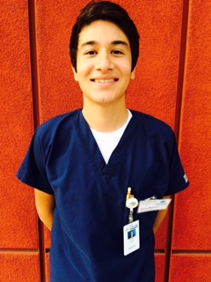
Hello my name is Victor Briones. As of June 2015 I am a Willows High School Graduate. I am a hard working young man who is constantly looking for opportunities to help me progress and become successful in life. I found out about the HESI (Health-Careers Exploration Summer Institute) program from my high school counselor. He recommended because he knew that I want to pursue a career in medical field. I knew I could not pass up this experience. This would be a great opportunity for me to experience a career in the medical field. My family supported my decision to be a part of HESI. Before completing this program I wanted to become a pediatrician. I had always dreamed of working in the medical field. I started off wanting to become a veterinarian, then moved on to physician, and ultimately decided pediatrics was the place for me. I love working with children.
HESI provided me the opportunity to experience a variety of different procedures. Among them was the opportunity to experience a Cesarean section, or C-section. This was definitely a highlight of my HESI experience. The moment I held a baby in the nursery, I realized that I was positive that pediatrics is the field for me. My whole experience in the mother baby center was definitely life changing and I am determined that a career in pediatrics is in my future. I am grateful to have been a part of the HESI program, because it allowed me to experience many areas of the medical field and ultimately decide what career I would be pursuing.

Nitza Cabral
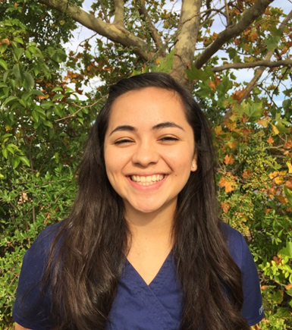
My name is Nitza Cabral; I am a 16 year old student at Hamilton High School, in the small town of Hamilton City. I heard about this program through my amazing teacher, Ms. Mello. Ever since taking her biology class my freshman year I have fallen in love with biological sciences. Ms. Mello instantly noticed how inspired I was with this subject and has since done everything she can to help guide me along my path to a medical career.
Going into this program I knew I wanted to be a surgeon, I also knew I was in love with neurology. However, after the experiences I’ve had going through different hospital rotations, I began to wonder if neuro truly was the route for me. On our last day of hospital rotations, I was able to witness a neurosurgical procedure, and knew this was indeed the career for me. Although my plans for the future were not changed, this program allowed me to reassess what I really want out of my life. Each day of this program, I grew more and more attached to the hospital. After the first week of rotations, I spent the entire weekend missing it. This program/experience has been absolutely incredible. I’ve learned so much about medical professions, and I have also been reminded of my extreme love for learning. These past three weeks are just a small taste of what my life could possibly be like forever, and that in itself, is enough to get me through the 15 years of medical school it’ll take to become a surgeon.

Lisa Ramirez
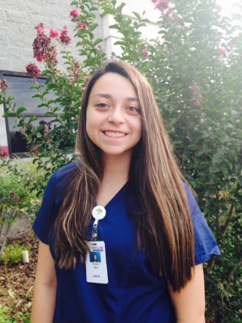
My name is Lisa Ramirez. I am 18 years-old and the eldest of three brothers. I just recently graduated from Princeton Jr/Sr High School and plan on attending CSU Chico in the fall to study Biological Sciences. I will then pursue a career in pediatrics because I love children and really want to help them to the best of my ability.
I pursued the HESI Program because of the amazing opportunities it could provide. I really wanted to experience the various careers in healthcare and what it would feel like to work in a hospital. HESI could help me determine if I really wanted to pursue a career in the medical field. It was a great opportunity I couldn’t pass up because it is not every day you get the chance to learn what it’s like to work in a hospital and actually see and feel the interesting things that happen in a hospital.
All the different departments I shadowed were wonderful. The staff were so nice and fun to be around and they were very informational. It was great getting to see surgeries and the various tests being ran. It was also nice helping the staff and getting to know them and their patients. There were a lot of interesting departments however, my favorite was Radiology. I am considering pursuing a career in Radiology instead of Pediatrics because it was fascinating. Radiology helps a lot of different departments in the hospital and all the different machines they use help doctors see what is going on inside the human body. It was really interesting getting to observe all the amazing things that happen in Radiology, but becoming a Pediatrician has always been what I wanted to do in life. Being in the HESI Program really opened my eyes and it really helped me get a feel of what it could be like to work in a hospital one day and what it takes to pursue a career in healthcare. I really enjoyed every single day and I am glad I was able to be a part of the HESI Program. I wish I could experience the program again.

Meagan King
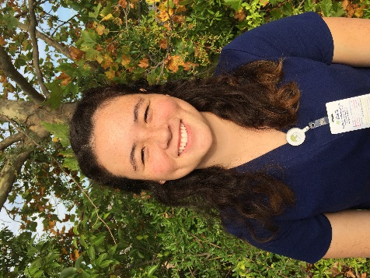
My name is Meagan King; I am 17 years old and go to Pleasant Valley high School. I heard about this program from my anatomy teacher, Mrs. Bruch. I have been lucky enough to have Mrs. Bruch twice; since freshman year my love for science has greatly increased. I’m extremely thankful for her passion for biology and anatomy. Without her, it is likely I wouldn’t have thought about a career in the medical field.
Coming into the program I wanted to be a cardiothoracic surgeon, having the opportunity to dissect a heart in my anatomy class made me realize how much I loved the heart.
After having the opportunity to see a full cardiac catheterization completely reassured me – at least I thought- that I wanted to be a heart surgeon. However, my experience on the neuro trauma floor has opened my eyes to the vast world of neurology. I have my preceptors to thank for my confusion; I am grateful for their thoroughness and passion for their career as they have impacted me in a great way. I am no longer sure of the surgical specialty, however, I know either way I will be extremely happy and grateful for this experience.
Gabriela Lozano
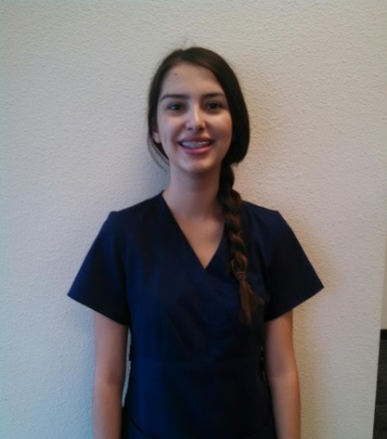
My name is Gabriela Lozano; I am an incoming senior at Hamilton High School and am seventeen years old. The HESI Program has been an amazing experience; I had the opportunity to see many different procedures and situations. It has been very beneficial and has granted me the opportunity to grow as a person and experience many new things. The hospital environment definitely suited me; I started to feel more comfortable towards the end of the program because I had built up a higher confidence. I noticed things ran more smoothly and I was able to speak with my preceptors more easily once I built up that confidence level.
My favorite experience was in the Emergency Room when I was able to see a large variety of patients from all age ranges coming in with different symptoms. Although many of the patients were classified as level four, I thought they were all very fascinating to observe. The one that intrigued me the most was a case of a gastric tube being fixed.
This program gave me the opportunity to experience the various careers in the medical field. My mindset has changed and I am unsure whether I want to become a general practitioner or registered nurse; I found a new interest in registered nursing.
Miriam Bravo
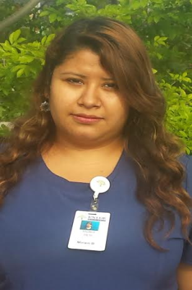
My name is Miriam Bravo. I recently graduated Hamilton High School and I am from Capay. I heard about the HESI program through my teachers at the school. I was very interested that we would be able to job shadow careers in the medical field. I wanted to be in the program because it is a great way to define what career I really wanted to pursue.
Since my freshman year, I wanted to be in the medical field. During my Sophomore year I went to a medical conference at UC Berkeley where I got to talk to different doctors and hear their inspiring stories. The doctor’s stories expired me to become more interested in the medical field.
When I heard about HESI program I knew it would be an opportunity to gain more experience. I wanted to explore the different branches of medical field. I’m so grateful I was able to be a part of this program. I saw amazing things like surgeries and a c-section. I feel lucky I had this amazing opportunity. Thank you to my instructors, preceptors, Butte College and Enloe for making this program happen. It was a great experience and I still plan to be a registered nurse in labor and delivery.
Bryn Lawrence
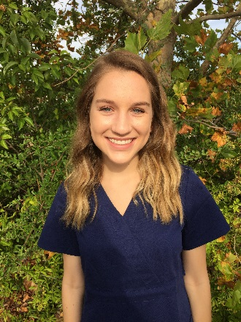
Hi, my name is Bryn Lawrence. I live in Chico, CA and I am going to be a senior at Pleasant Valley High School this coming year. I joined HESI to help narrow my focus and determine what medical career I wanted to pursue. Before I joined this program, I had no idea what I wanted to do or what I wanted to be; all I knew was that I wanted to pursue a career in the medical field.
This program was unforgettable and everything that I hoped it to be. I got to see and experience so many incredible things like different type of surgeries, different machines/ procedures, and many other amazing things. Additionally, I got to meet some of the strongest and inspiring people I have ever met. I was also able to job shadow so many wonderful, rewarding careers and let me just say, it was the opportunity of a lifetime. Coming into this program, I was completely lost. Coming out of this program, I know exactly what I want to do with my life. I got the chance to stand in the surgery room during an orthopedic surgery where I met an anesthesiologist named Dr. Ertner. I was standing in the surgery room against the corner when Dr. Ertner called me over to stand by him. He was so welcoming, extremely funny, and informative. It was so inspiring to watch Dr. Ertner do his job. His kindness, positivity, and most of all, humor, are something I’ll never forget. Watching Dr. Ertner take care of his patient gave me the push of encouragement that I was looking for. Coming out of that surgery room, I realized that I wanted to become an anesthesiologist. I now see myself majoring in biology, earning my Bachelor’s degree, attending medical school, entering a residency program, and fulfilling my newfound dream of becoming an anesthesiologist. I am so grateful for everything that I got to experience in HESI and for everyone’s hard work to make this happen. This program is something I’ll remember for the rest of my life. Thank you so much Mello, Trudy, and Susan; this wouldn’t have happened without you.

Diana Parra
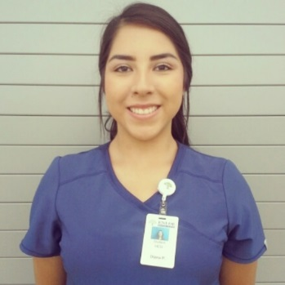
My name is Diana Parra, I’m currently 18 years old and a newly graduate from Orland High School. I came into this program knowing that I wanted to be a Registered Nurse, but this program gave me a definite answer. After experiencing all the different rotations that we had I knew that nursing was for me. This program taught me how rewarding a job in the medical field is and I want to experience that feeling after coming home from work every day.
I also did experience some sad moments and it opened my eyes to realize that everything in a hospital isn’t always saving lives, sometimes there’s live that can’t be saved. I believe this program should continue, not only has it helped me choose my career, but it has also helped me grow into a more confident person and every high school student that is interested in the medical field should get a chance to participate in something as amazing as this HESI program. I’ll be forever thankful for this amazing experience that has been provided to us for the first time in this area.
The one experience that I will never forget is experiencing a trauma and following the patient through the recovery process. It was hard to see something this impactful, but it really helped me realize that both smiles and tears may come with the job. This experience also taught me that if I do not go into nursing, which is highly doubtful, I would also consider respiratory therapy. Respiratory therapy was exciting and I know that that is a career that that I would enjoy. Not only am I walking out from this program with so many experiences, but I’m also walking out with new friends and new skills that I learned throughout these three weeks and for that I am thankful.

Marialena Palacios
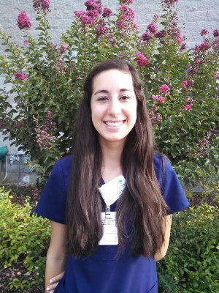
My name is Marialena Palacios, I am eighteen years old and I am the third child out of five children, and I will be the first to attend college. I recently graduated from Willows High school. This fall I will be attending the University of California Davis and majoring in Biological Sciences, in hopes to become a Pediatrician. When I heard about this program from my Anatomy teacher, four bullet points popped into my head; one this program will be a resume builder, two this program will be a good internship experience for college, three a great exposure to the medical field, and four it will be an advantage to have before I even enter Davis. I prepared all my paperwork and requirements for the interview. Before the interview I was reviewing possible questions the HESI instructors might ask, I was preparing myself for a great interview. I jumped with excitement when I received the email of acceptance to the HESI.
The HESI experience has changed my view in the medical field completely, I have confirmed my decision into staying in a health career field. These past three weeks have really pushed and shaped my goals. In the HESI Program I experienced several surgeries, C-section, natural birth, and speech impediment. I have seen the motivation, dedication, and determination of my preceptors and I really appreciate the knowledge they fed me during my rotations.
I am proud and glad I got to participate in the first HESI Program. My preceptors motivated me and pushed me to go big and get more degrees because all the education you can receive will pay off.
The best experience I had at Enloe was at the Mother Baby Center. I saw a C-section and a natural birth. After seeing these two procedures I never wanted to leave. That day I reflected on my career decision of becoming a Pediatrician and thought that my second choice will be Obstetrician. I also experienced Speech Therapy and I was amazed to see that speech therapy was more than helping patients in their language but also swallowing, memory, right and left hemisphere, and voice.
I did not realize HESI would have such a big impact on my life. I really appreciate getting chosen and given this opportunity. HESI was not a job shadow observation course it was a hands-on experience in the field with the nurses and doctors and I really enjoyed these rotations. I meet some amazing students with similar interests in the medical field. I made connections and relationships with these amazing people. I will never lose connection with my fellow students because they are my pals! HESI is the best program you will ever be a part of if you want to be in the medical field. I gained more medical terminology, proper vital signs, one to one patient contact, professional insight and advice, and viewed real life situations. HESI is ahead of the curve and exceeds any expectations.
I joined the HESI program for a better understanding of what I would like to pursue as a career in the medical field. This program has exceeded my expectations and if I could; I would definitely do it again. In the short three weeks it has made me question which profession I would want to pursue. I’ve experienced the realms of becoming a professional gurney maker; to anticipating a surgery; to being a part of a patient’s healing process and to expanding my knowledge of how much patience and compassion this hospital has as a whole.

Mireya Lopez
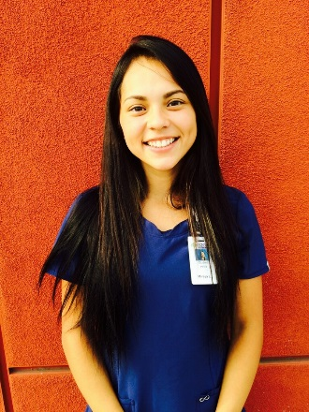
My name is Mireya Lopez. I am an Orland High School graduate. In the fall, I will attend Santa Rosa Junior College. I will major in Biology/Chemistry for my Associate’s Degree, then I will transfer into UC Davis and then transfer into UC Davis Medical School in hopes of becoming a general surgeon, preferably trauma. I have always been a very goal oriented and determined young lady. I’ve tried to exceed the expectations I hold upon myself by involving myself into everything I can get my hands on.
All my life I have known exactly who and what I wanted to be. Until last week when I entered the Enloe Medical Rehab Center. As soon as I started interacting with the patients, I was locked in. I was incredible how inspiring these people that have lost it all still have the desire, hope and most of all strength to get up every day and still believe. The people that instill this hope and desire are the therapists. I can definitely say the HESI (Health-Careers Exploration Summer Institute) program has changed my future. It has helped me enhance my skills and it has put ignited my drive and determination to pursue a career in the medical field.
Jesse Marcella
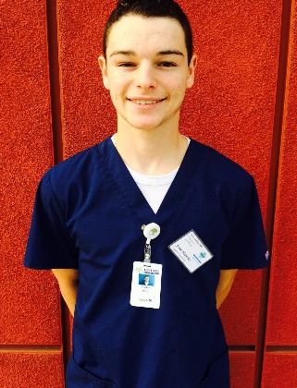
Hello, my name is Jesse Marcella. I am a recent graduate from Hamilton High School. This next fall, I will be attending Butte College. I am currently enrolled in 12 units and plan on excelling in all courses.
I was first introduced to the HESI program by my English teacher ast semester. She had once overheard me say I wanted to become a registered nurse when I was older. The HESI program was perfect for me because I had no idea what field of nursing I wanted to pursue.
During my HESI experience, I got to witness and be a part of many things that most people won’t be able to say they’ve ever seen before. Because of the HESI program, my desire and passion to become a registered nurse has flourished even more then I could have imagined before I started the program. Also, the HESI program has led to me decide that one day, I would like to become a trauma nurse. This occurred to me after my emergency room rotation, which just so happened to also be my favorite rotation during the whole program as well! I am so thankful for all the preceptors and instructors who have made this program possible.
Araceli Pompa
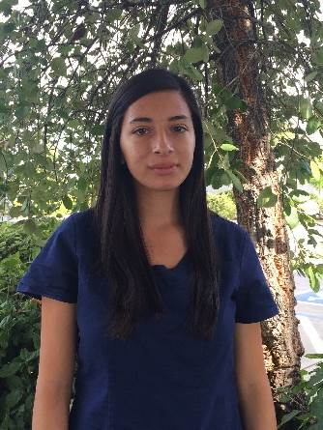
My name is Araceli Pompa. I am a recent graduate from Orland High School. This fall, I plan to attend Chico State where I will major in pre-nursing. Before this program, I inspired to become a registered nurse and specialized in pediatrics. I learn about this program from my high school science teacher. She told me that this was a great opportunity for inspiring nurse. I ultimately decide to be a part of this program because it would benefit me as I further my education. I knew this program would help me determine if the medical field is right for me.
This program has allowed me to experience and see the different aspects of the hospital and rehabilitation center. During the program, I got to experience so much. I got to witness procedures performed on patients at the CATH Lab and Nuclear Medicine. Through the many rotations, I was able to meet and interact with patients in the hospital and rehabilitation center. The rotation I enjoyed the most was the Mother Baby Center. During this rotation, I was able to meet the mothers and their newborns. The best part of the rotation was being able to see the newborns in the special care unit. I loved watching and taking care of the newborns. This rotation along with the program has help me determine that the medical field is right for me. After the program, I still inspire to become a registered nurse and hope to specialize in pediatrics.

Lola Gonzalez
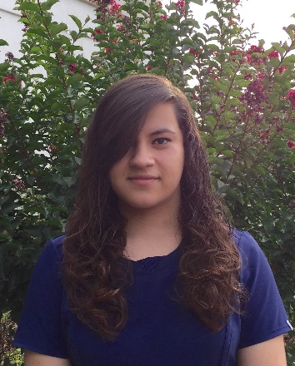
My name is Lola Gonzalez and I'm a recent graduate of Princeton High School. I am going to attend Chico State University and major in pre-nursing so I can become a registered nurse. When I got into the program I had no idea what I was getting into; it was an entirely new experience for everyone, and there was really no way of determining how well things were going to go. However, I knew it was going to be a great experience for me because I knew I wanted to be in the medical field, and this program really gave me a better idea of what career I wanted to pursue.
My experience in the hospital helped me determine whether or not I truly wanted to pursue a career in nursing. After shadowing many registered nurses in many different departments, I realized that the career that appealed to me the most was that of a neonatal nurse. I've wanted to be a registered nurse ever since I was young, so the change wasn't too major, but my experience in that department made me realize that I loved working with babies and mothers, and I felt completely natural being in that type of environment.

Kassiah Henderson
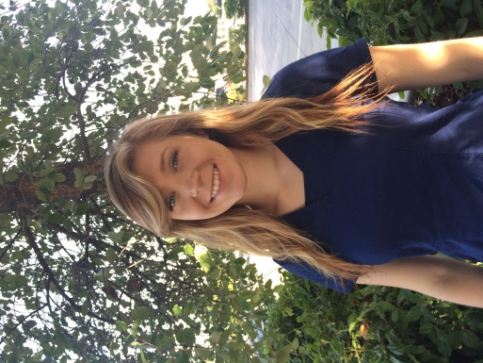
I am 16 and I attend Core Butte high school and Butte College. I am entering my junior year this fall and have just recently decided that I want to pursue a career in the medical field. Knowing the potentially rigorous courses and requirements, I searched for help within my high school classes, and just happened to run into the HESI program through one of my teachers. The easiest way to describe the way this program has made me feel is, hungry. I am hungry for more. At the end of each day I didn’t want to go home. I was fascinated and I knew that this is what I wanted my future to look like. The people were one of the most inspiring parts. All of the preceptors were amazing. They never stopped telling me about the department they worked in, how they got there, the best and least favorite parts of their jobs. I even got college advice from everyone. In high school, everyone asks you what you want to do after you graduate. Making the decision on what you want to do for the rest of your life is a lot harder than it looks. It is stressful, and scary, but exciting and important. I’ve never had a definite answer until now. I will be a trauma surgeon.

