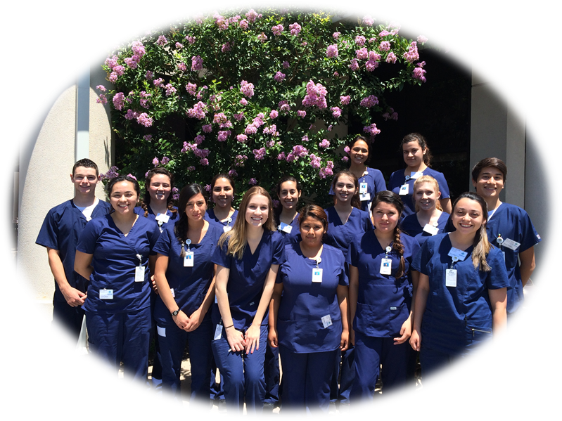
THANK YOU!
From the students participating in the
Health-Careers Exploration Summer Institute (HESI) Program
through the Health Workforce Initiative (HWI) at Butte College

