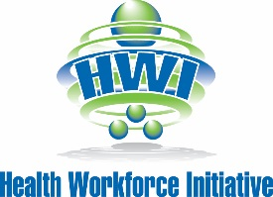

HEALTH-CAREERS EXPLORATION SUMMER INSTITUTE (HESI)

GUIDELINES FOR FINAL PRESENTATIONS

To reinforce your learning from this summer institute, you will be providing a final presentation to Shasta Regional Medical Center staff and partners, family, and friends on June 30, 2016 at 5:30PM.

You will create a PowerPoint for this presentation. Neatness and professional quality are very important.
Your presentation must include:

- A written introduction including your name, age, high school, and a picture in your HESI uniform. (30 - 45 seconds)

- Your expectations before starting the internship. (1 - 2 minutes)
  - What did you think HESI was going to be like?
  - Why did you apply?
  - What were your career goals before the HESI?

- Rotations you completed during your internship. (1 - 2 minutes)
- Identify the two rotations that you enjoyed best.
- Discuss what you saw, staff you met, and new terminology you learned.

- Reflecting back on the overall experience. (1 - 2 minutes)
- How was what you experienced different from what you expected?
- How did this experience change you?
- Do you have a new career goal as a result of HESI?

- Thanking staff and board members for the opportunity. (30 - 45 seconds)
- Consider including specific departments and staff members; executives and board members; HESI coordinators and supervisors that managed this program; Health Career Pathway teachers; supportive family and friends, etc.

Your total presentation should be between 5 - 10 minutes. You are assigned to practice it at home a few times to be sure you are comfortable speaking about it professionally.

